**MC205**

**Probability and statistics**

**LAB**



**Name** - Himanshu Singh

**Roll No. -** DTU/2K16/MC/036

Department of applied mathematics

Delhi Technological University

**Programmed by IBM SPSS v21**

**INDEX**

|  |  |  |  |
| --- | --- | --- | --- |
| **S.No.** | **Date** | **Topic** | **Signature**  **/remarks** |
| **1** | **15/07/17** | **Transportation of data from text and excel files into spss** |  |
| **2** | **22/07/17** | **Entering of data in spss in variable view and data view** |  |
| **3** | **5/08/17** | **Merging of data on the basis of cases and varibales** |  |
| **4** | **15/08/17** | **Splitting and filtering of data** |  |
| **5** | **25/08/17** | **Write a program to find and replace missing values in data.** |  |
| **6** | **25/08/17** | **Give a program for finding the sum of obtained marks in a set of Multiple Choice Questions for 5 students** |  |
| **7** | **5/09/17** | **Pictorial representation of data.** |  |
|  |  |  |  |
|  |  |  |  |
|  |  |  |  |
|  |  |  |  |
|  |  |  |  |
|  |  |  |  |
|  |  |  |  |

**Practical 1: Transporting dataset to SPSS editor**

**Inputs:** Lab7Start v5.xlss, textforspss.txt

**Procedure followed:** Through Excel

**Commands:** File > Open > Data

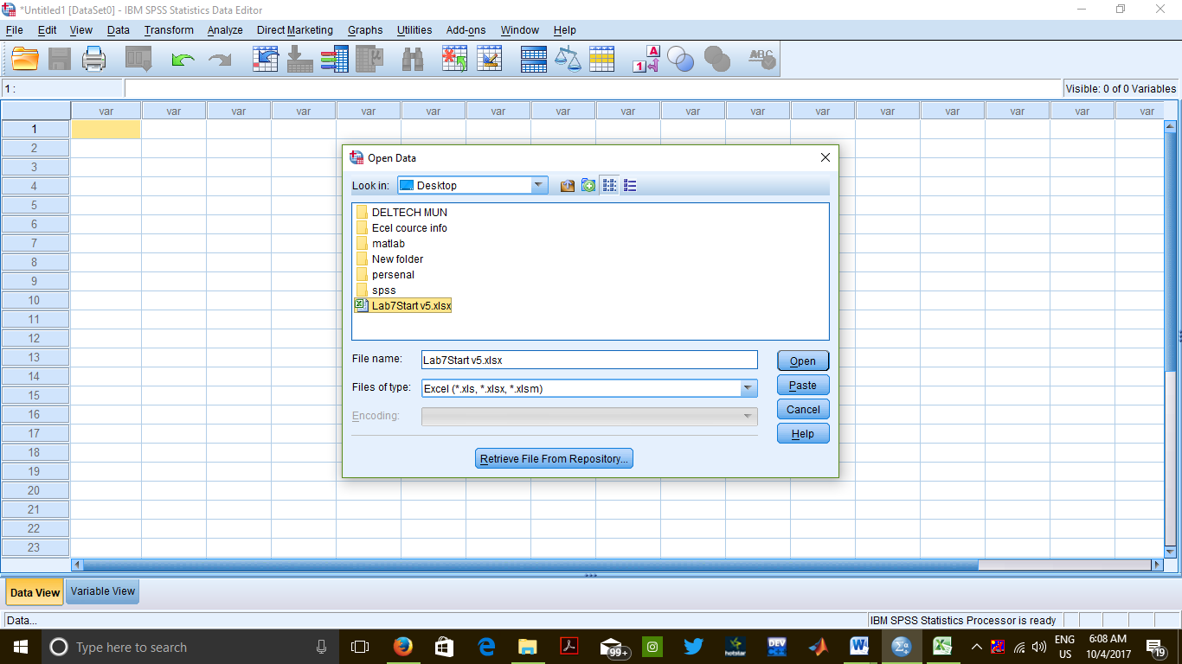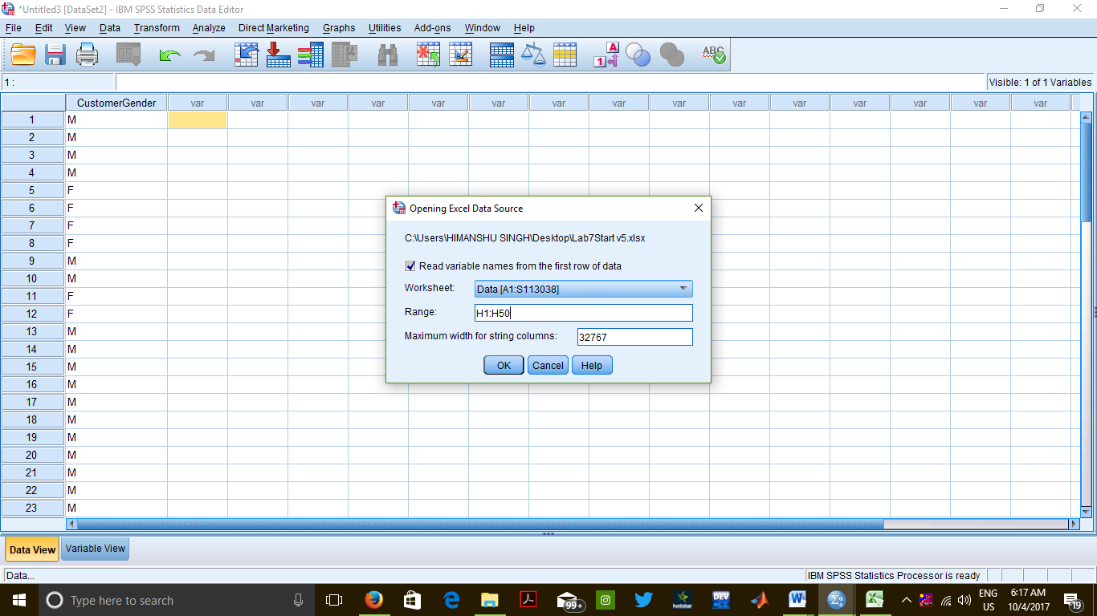

**Output**

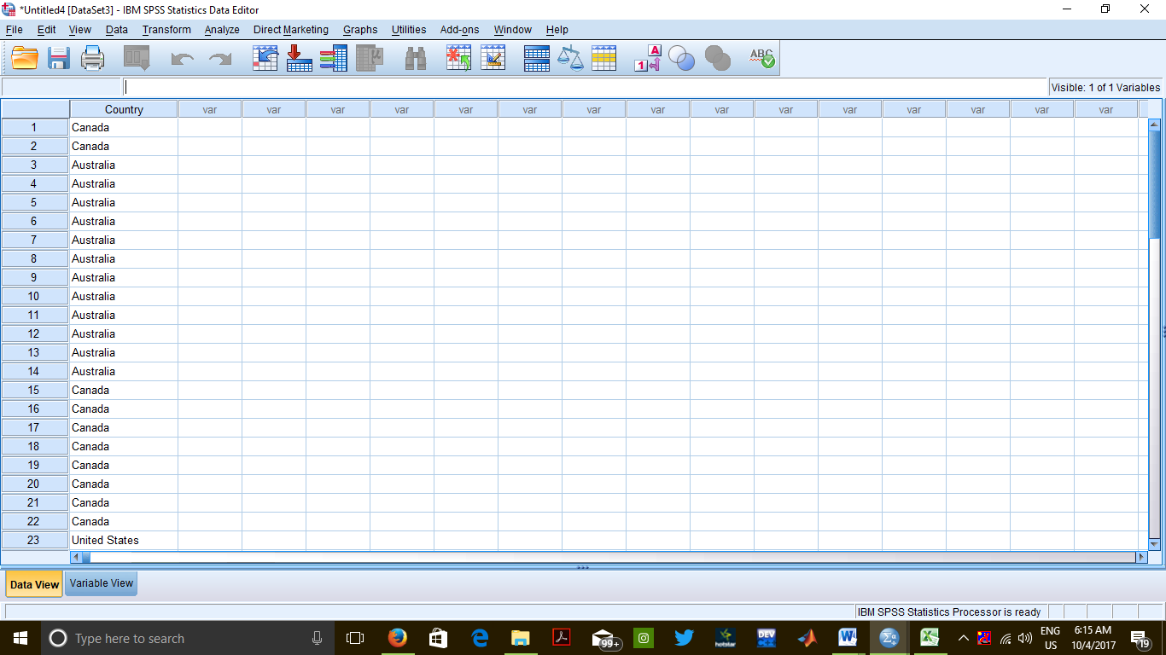**Data View**

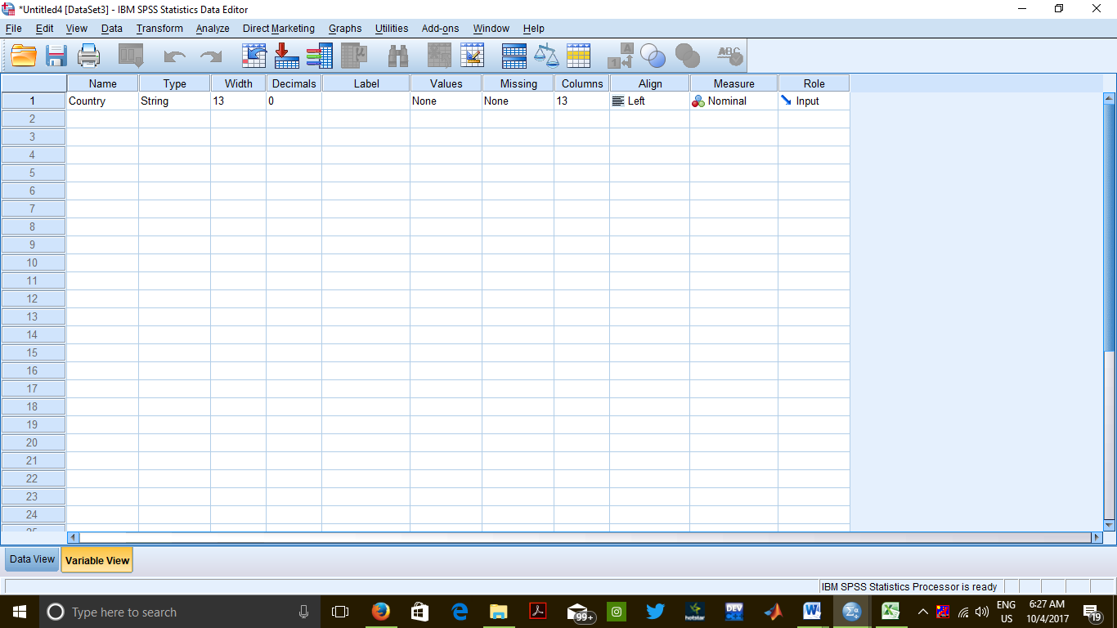

**Variable view**

**THROUGH TEXT FILE**

**Commands:** File > Read Text Data

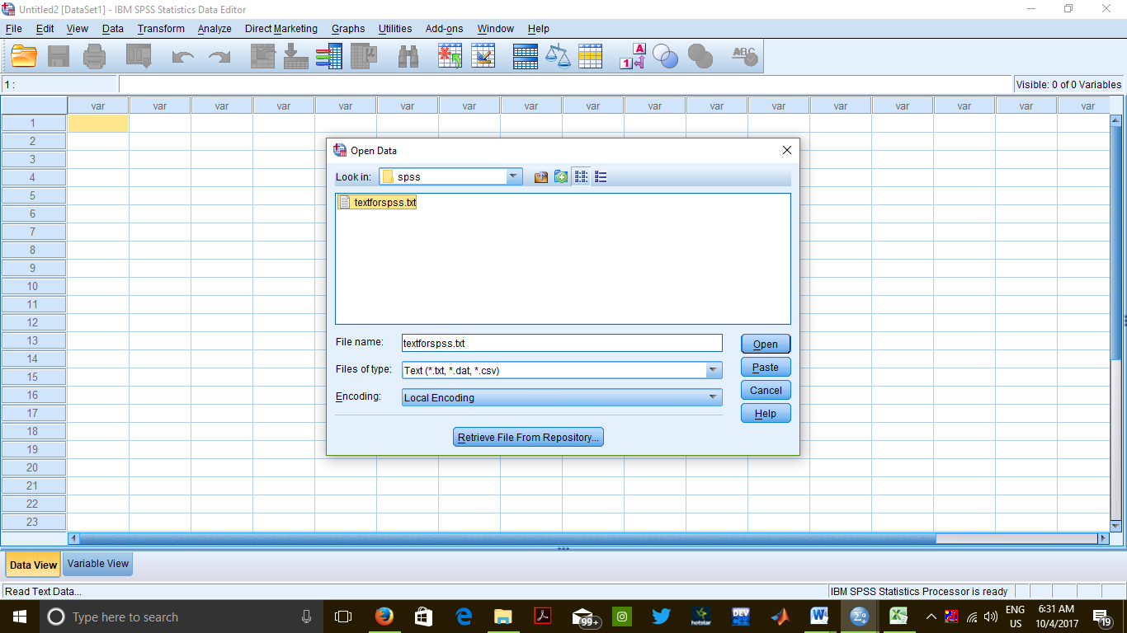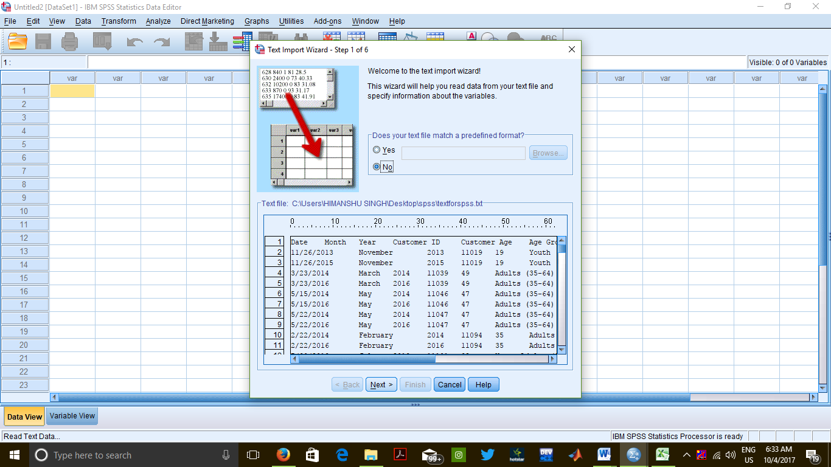

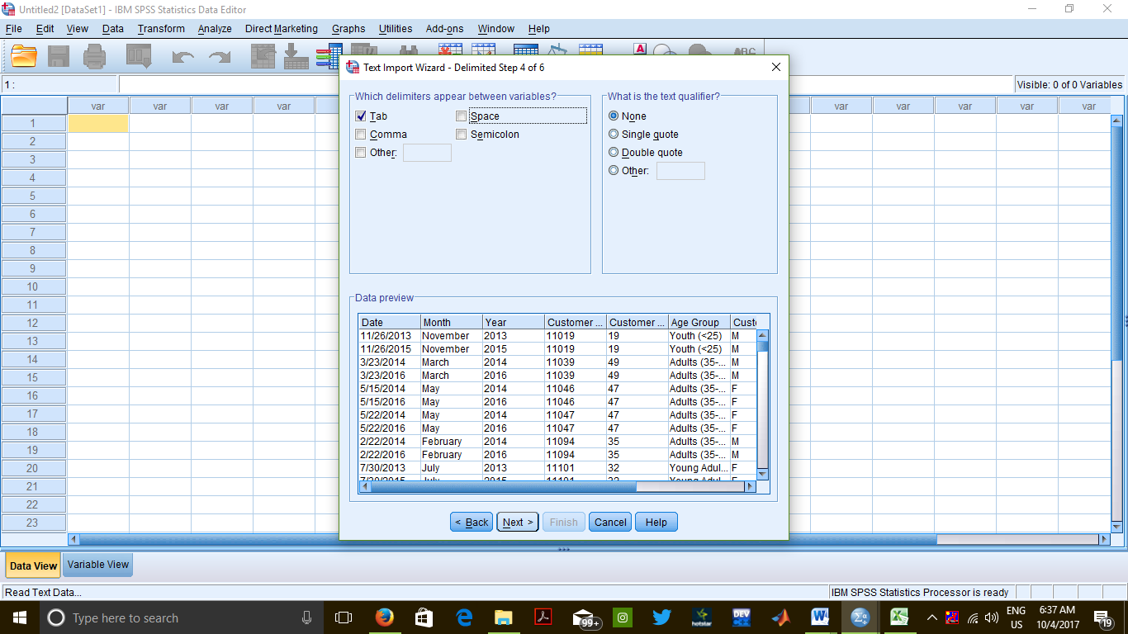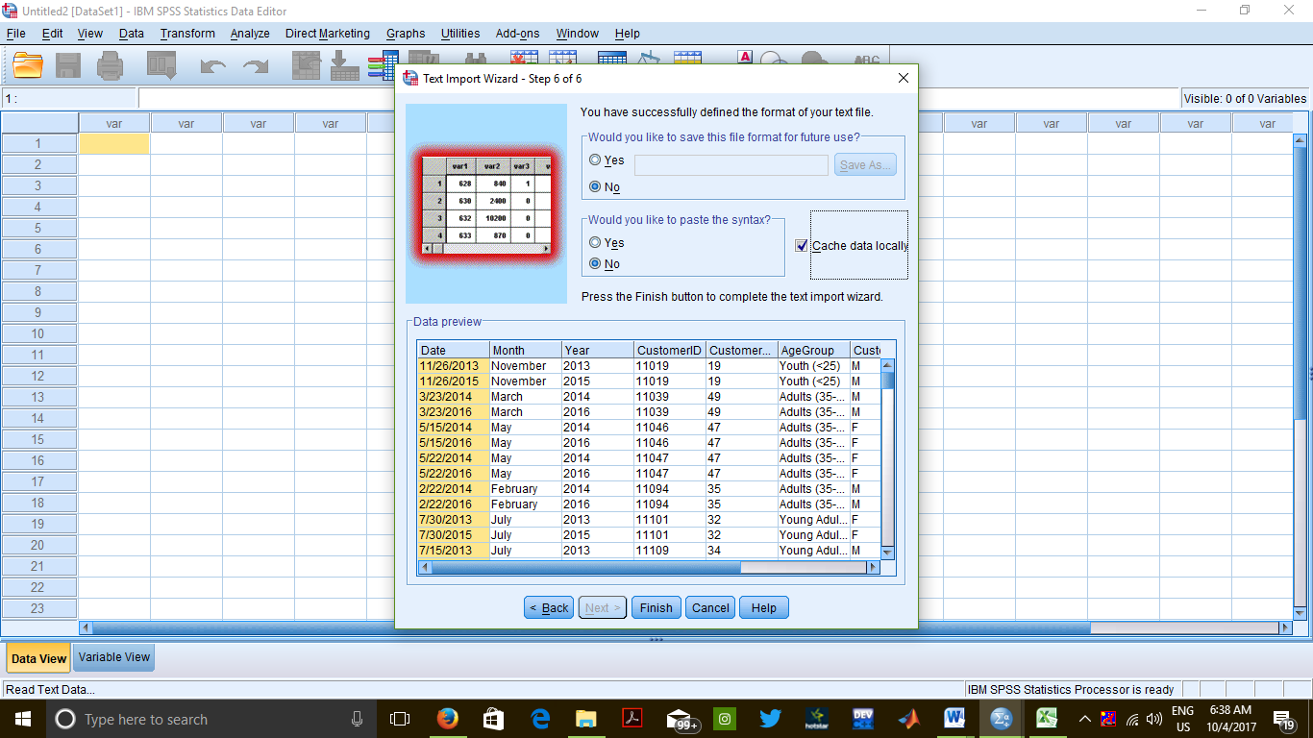

**Output**

Variable view

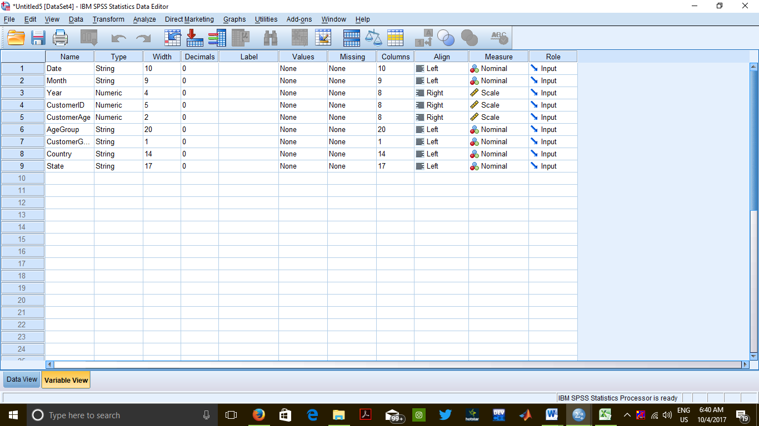

Data view

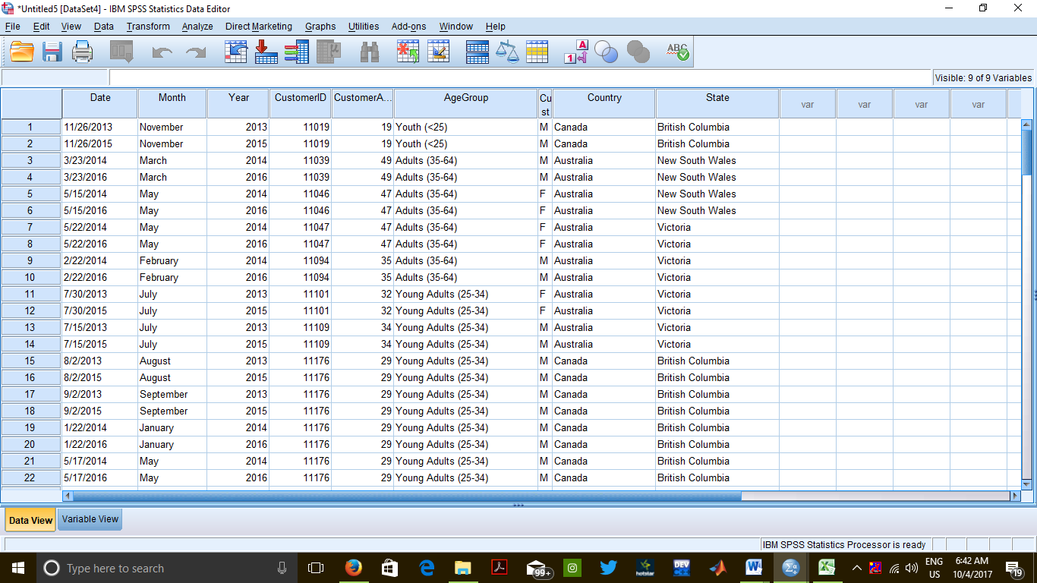

**CONCLUSION**

Any document file in excel, text etc. formats can be transported to SPSS editor window.

**PRECAUTIONS**

There should be proper spacing between variables in a text in a file.

Extensions of the files should be strictly taken care of.

**Practical 2: Inputting Data in Spss**

Inputs – input data types at variable view

Input full data in data view

Commands - File > open > new

Variable view

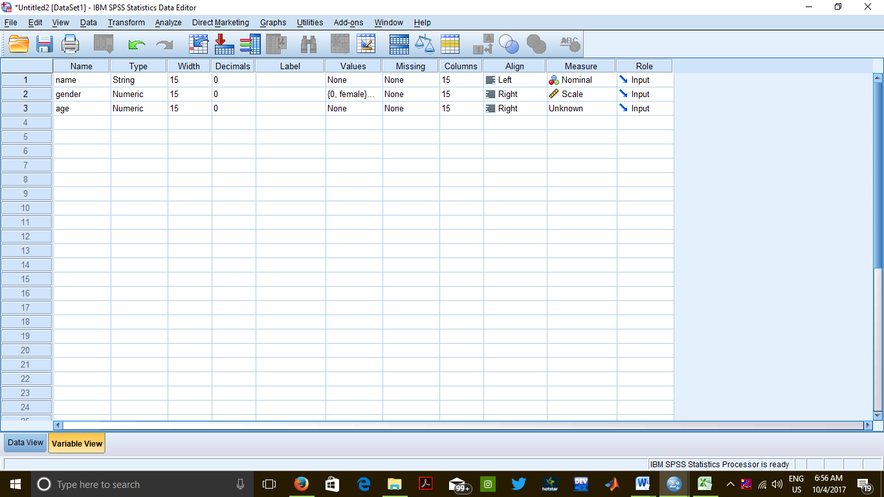

Data view

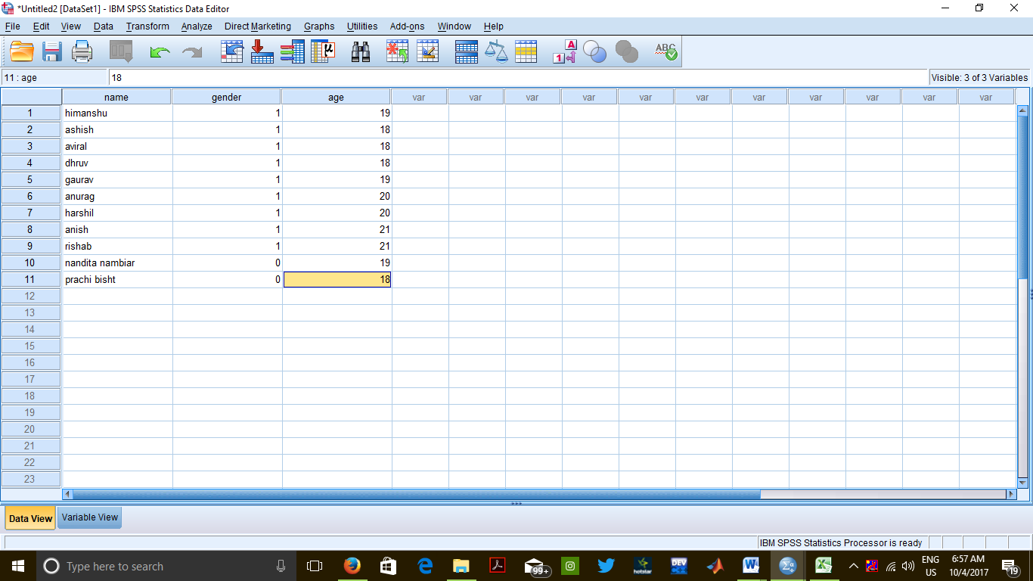

CONCLUSION

A file can be made in spss by defining variables and their attributes and data can

be then entered and stored accordingly.

PRECAUTIONS

Attributes of a variable must be defined carefully keeping in view the requirement

of the variable.

Extensions of the files should be strictly taken care of.

**Practical 3: By using 4 files, demonstrate**

**1. Merging of cases**

**2. Merging of variable value**

**a) Both files provide cases**

**b) Non active data set is keyed table**

**c) Active data set is keyed table**

**INPUTS** 3 files File1, File2, File3 and file 4 are created in SPSS in which the user defines the variables, their attributes and enters the data.

**PROCEDURE**

**MERGING OF CASES**: Open FILE1.sav - File > Open > Data

Data> Merge Cases > Add cases

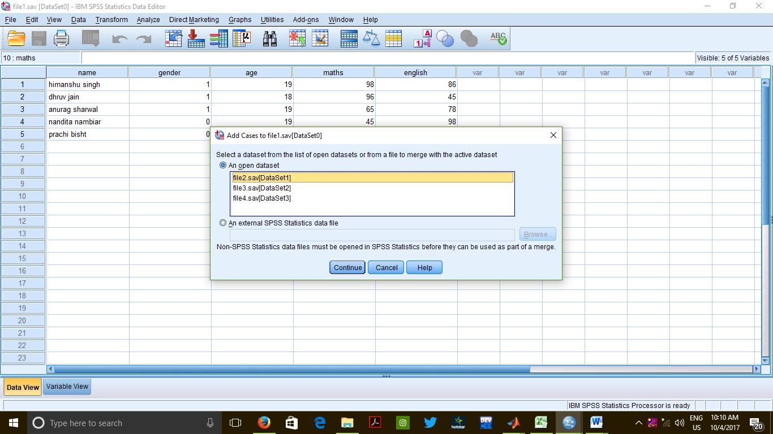

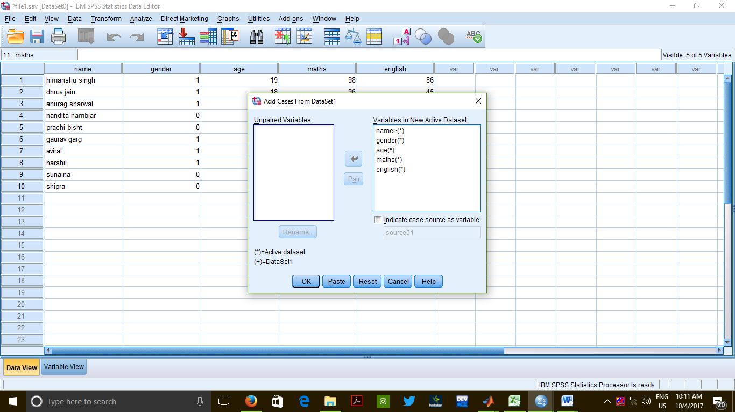

Merged data view of file1 and file2

**OUTPUT**

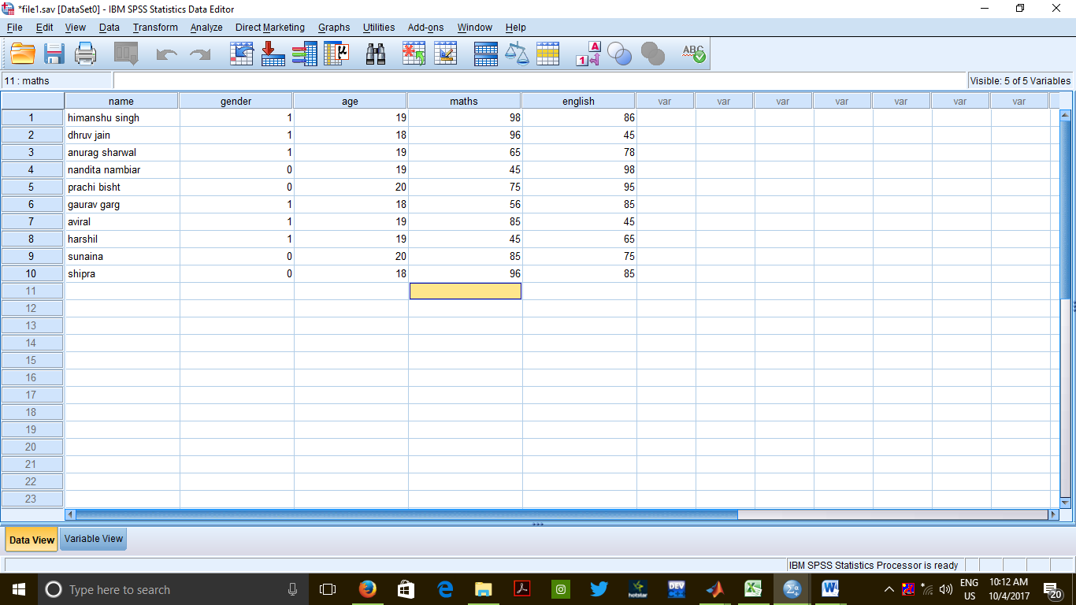

**MERGING OF CASES – when short form of other variable is written in another file**

Data> merge sort > cases

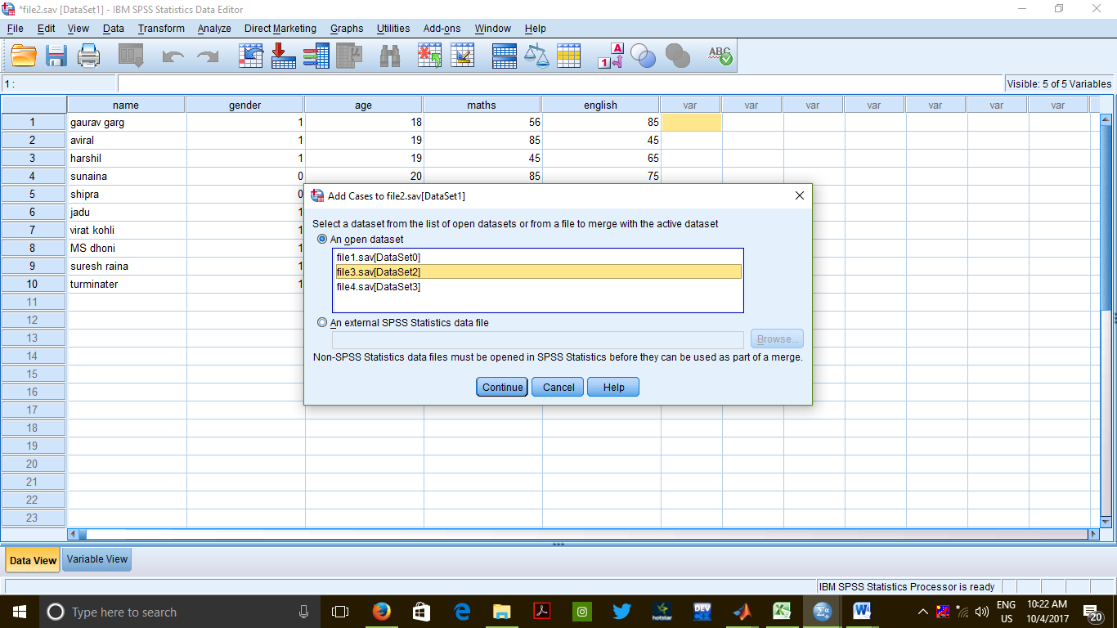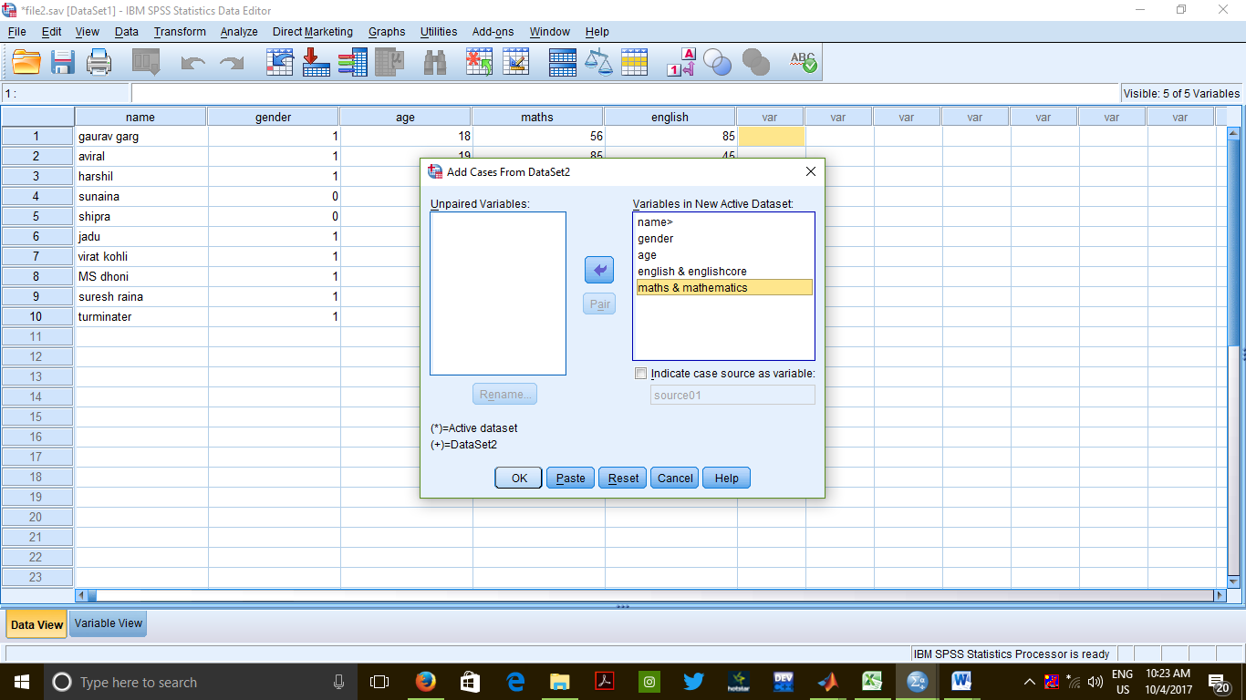

**OUTPUT**

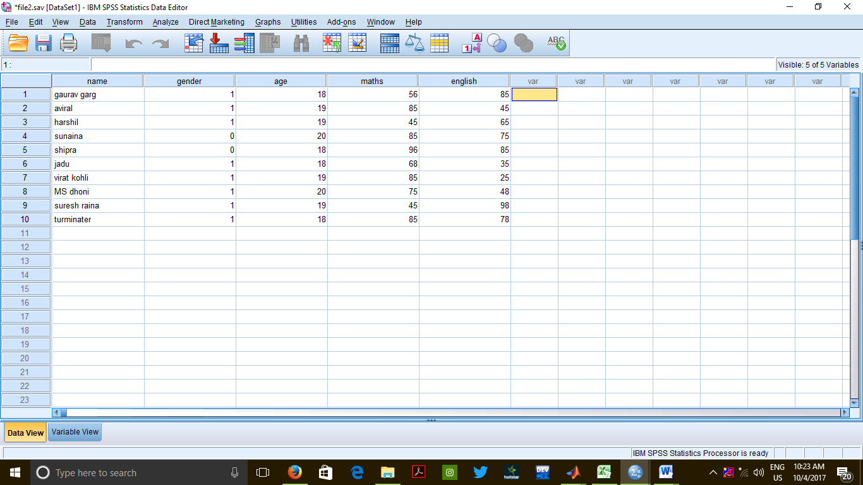

**Merging of Variable Values**

Data> Merge Cases > Add variables

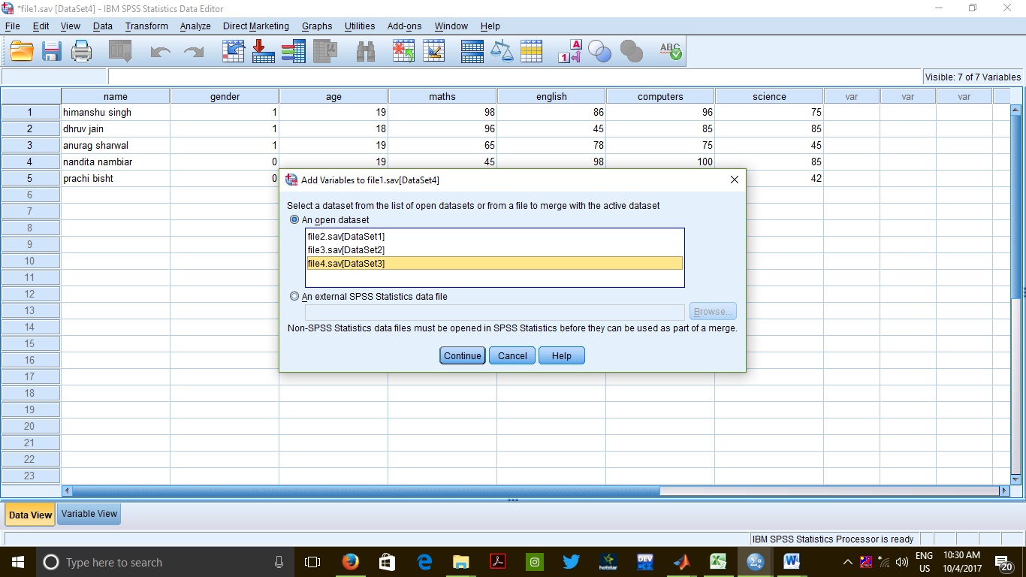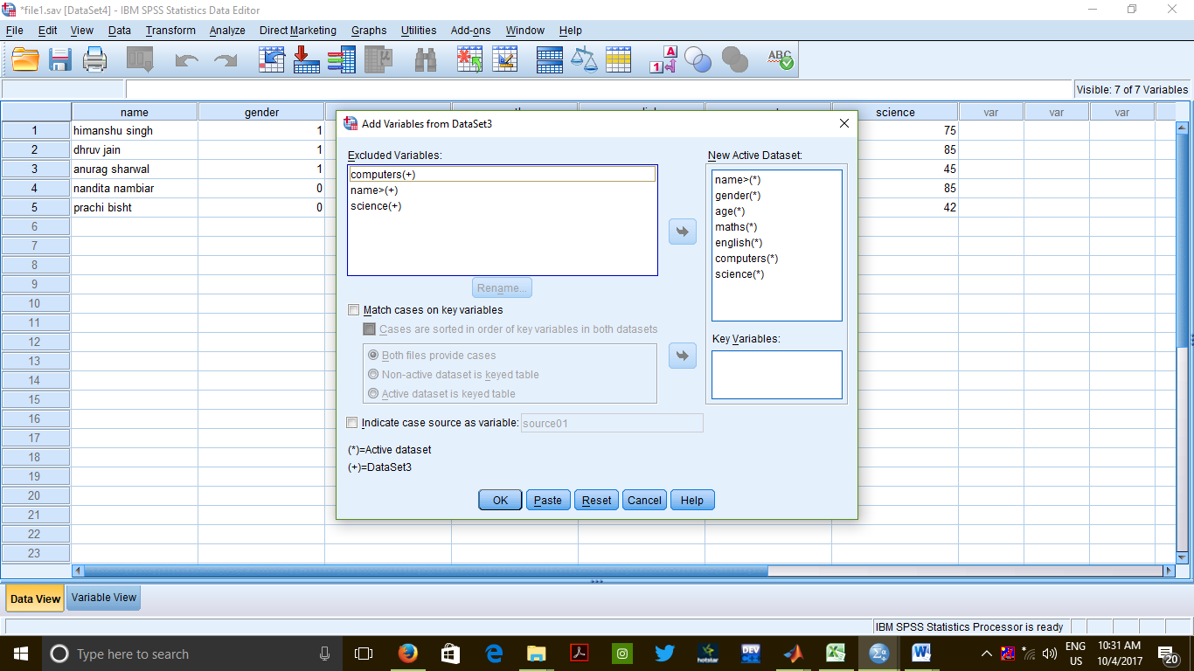

**OUTPUT**

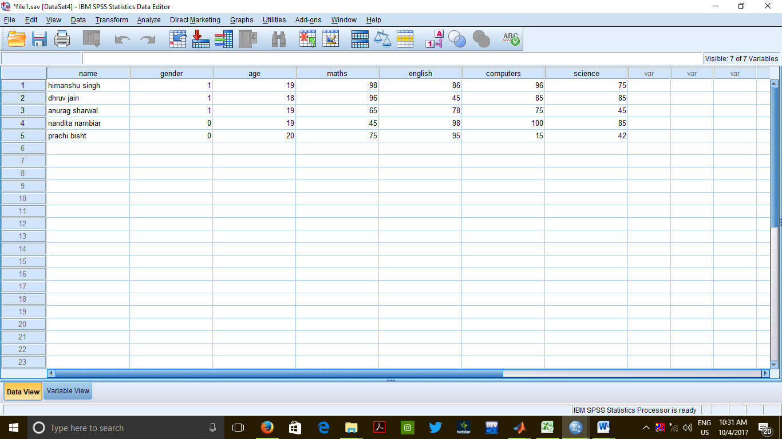

**CONCLUSION**

We can conclude that in SPSS, we can either merge complete files with one another or we can add variables of one file to the variables of another file.

**PRECAUTIONS**

While adding variables to a file, make sure both the files were sorted in ascending order.

While merging cases, the unpaired variables should be properly renamed and then paired accordingly.

**Practical 4:**

Demonstrate the following in a SPSS file

1. Filtering of Data
2. Splitting of File According to Variable(s)

**Filtering Of Data**

1. Open "file2" from the samples provided along with the software.
2. Data > Select Cases
3. Choose the radio button saying "If condition is satisfied".
4. Click on the "if" button.
5. Specify the condition in the dialog box that opens.
6. Click on "Continue".
7. Click on "OK".

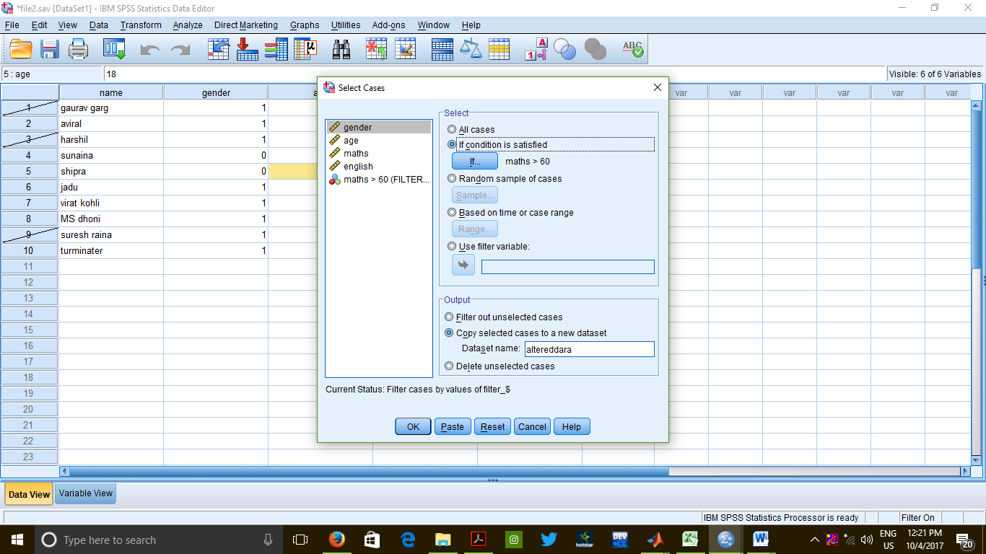

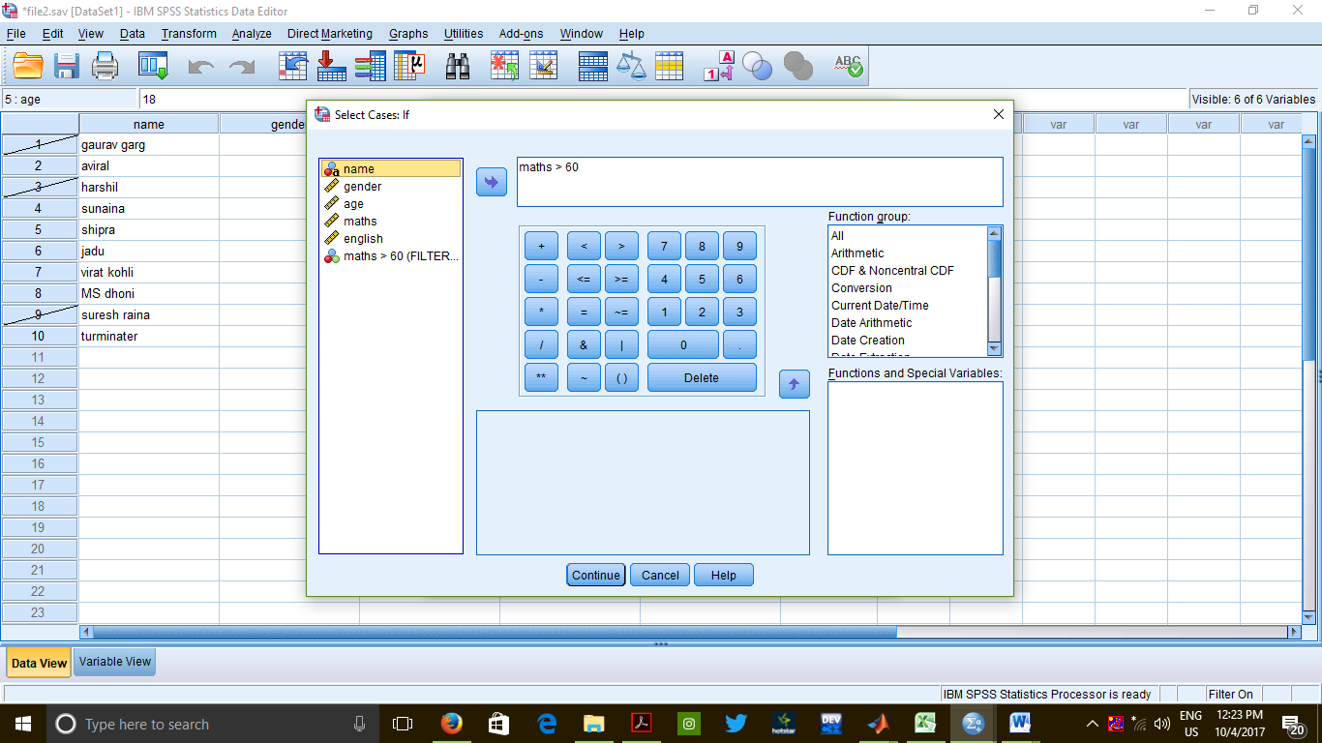

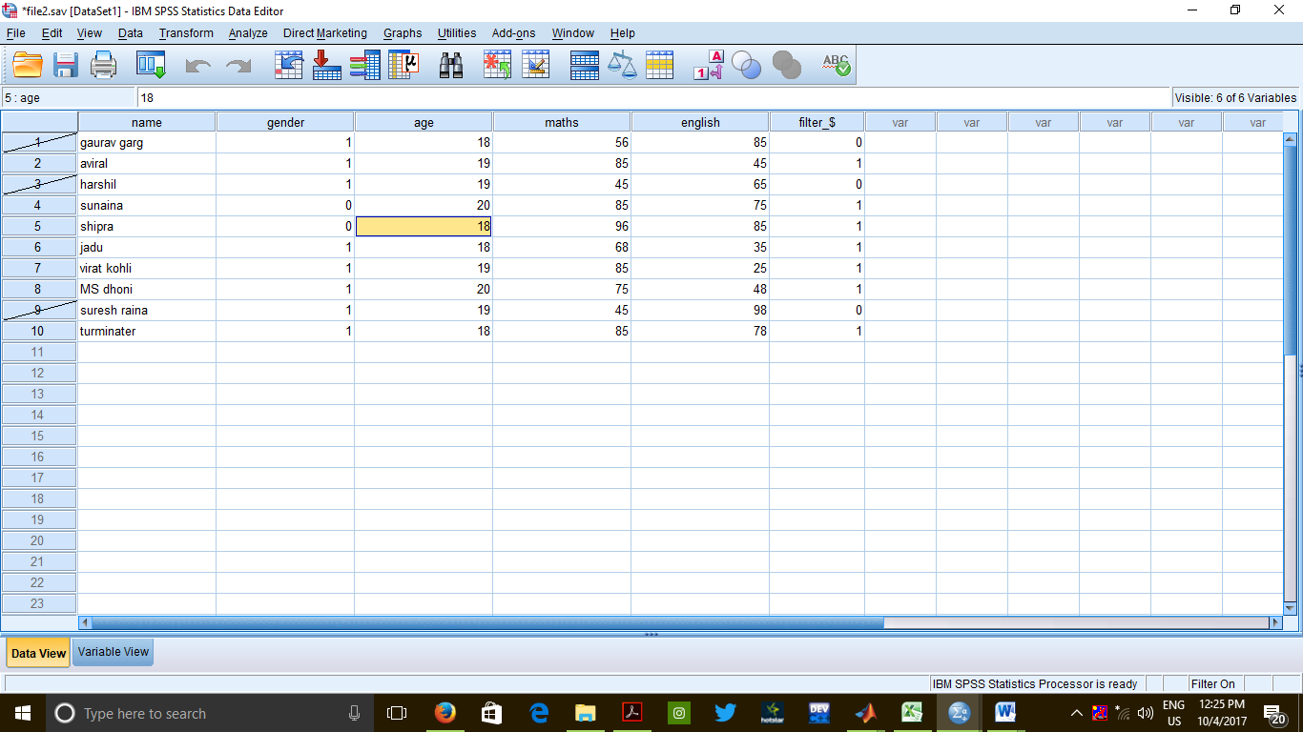data view of file 2

**OUTPUT**

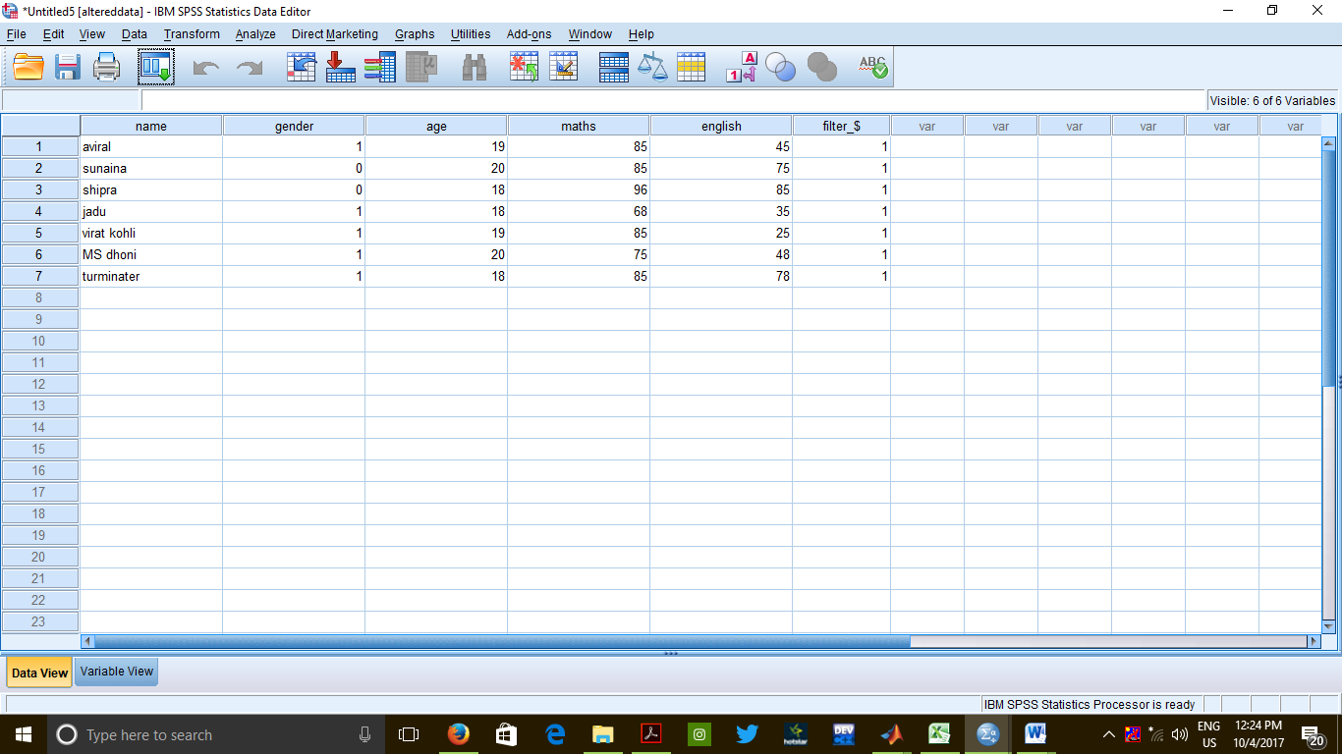data view of altereddata

**Splitting of File According to Variable(s)**

File : "file2.sav"

Commands – file> data> split files

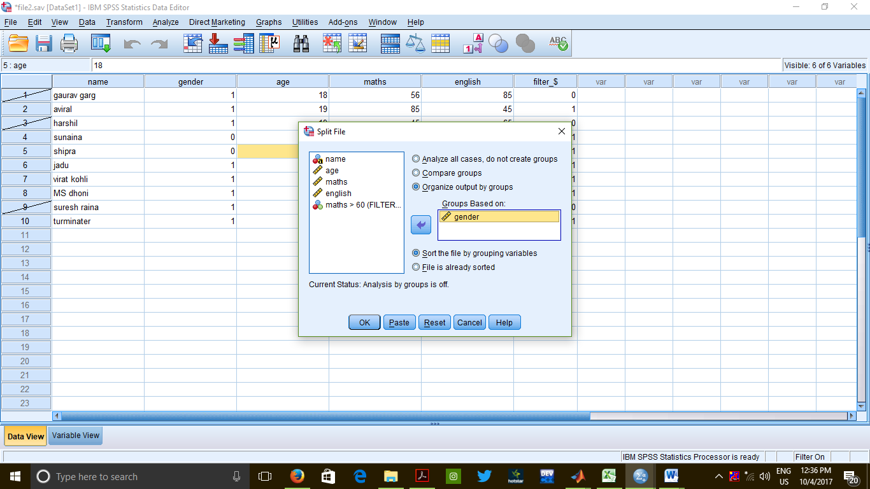

**OUTPUT**

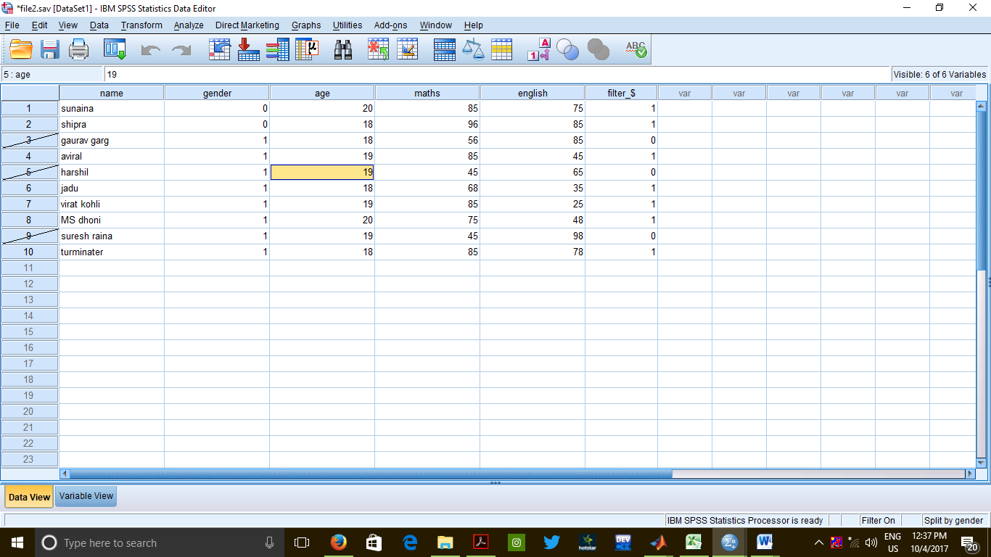

Data view of spitted data into males and females 0=females, 1= males.

CONCLUSION :

Small extracts of very large document files can be viewed easily through splitting

and filtering of data on given specific cases.

PRECAUTIONS :

* Extensions of the files should be strictly taken care of.
* The conditional statements on the basis of which the file is being split should be

given carefully.

**Practical 5**

**Write a program to find and replace missing values in data.**

**INPUT:**

salesforproduct.sav

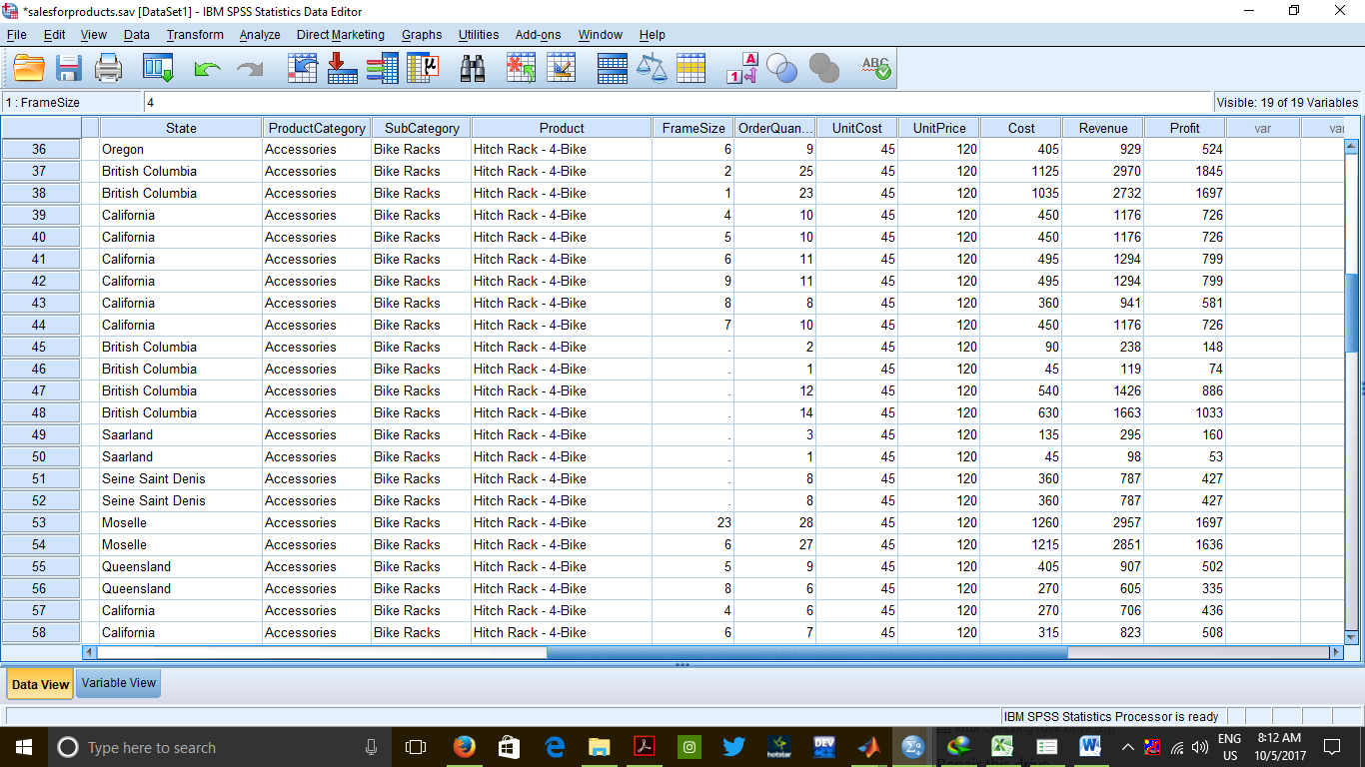

**Data view of salesforproduct.sav while data in frame size is missing**

PROCEDURE:

1. Transform --> Replace Missing Values
2. Select the variable which contains missing values and add and rename it according to convenience and press the change button.

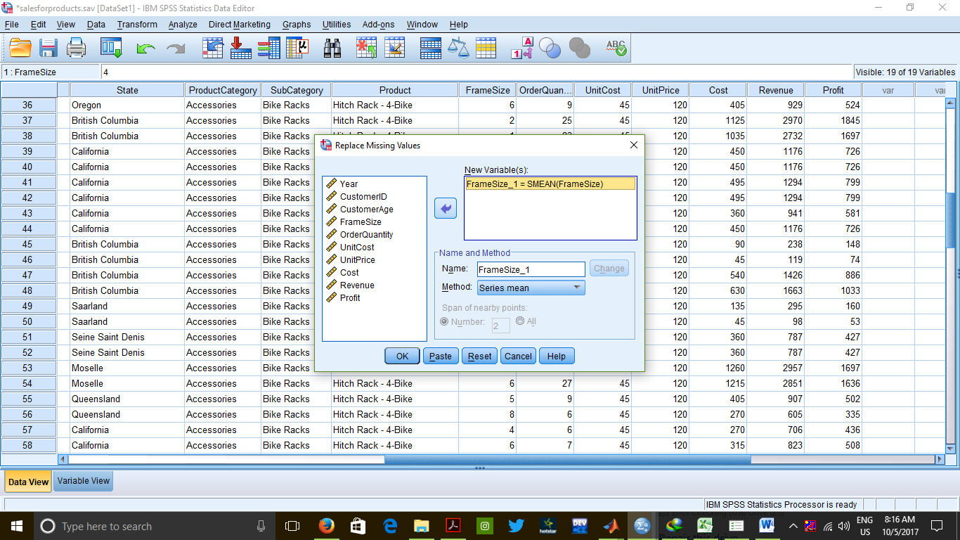

1. Than the value will be replaced as shown below

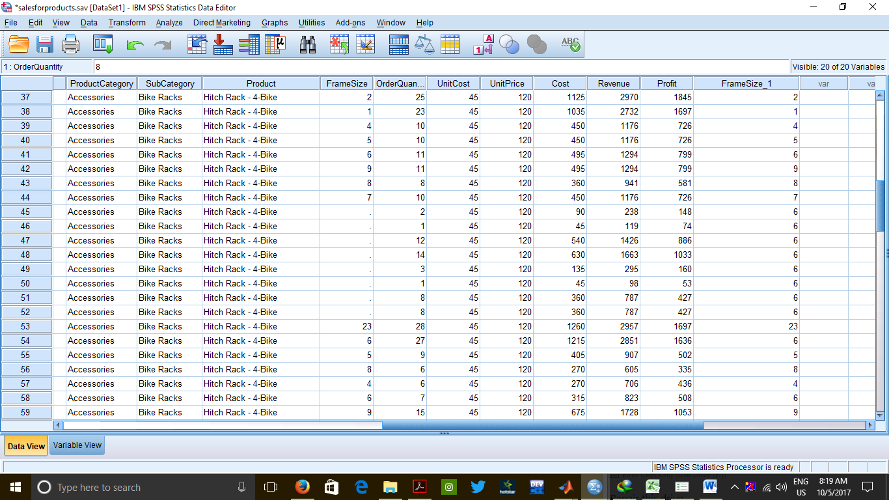

**Frame size have missing value in new column framesize_1**

CONCLUSION :

Missing values of certain fields is calculated by applying various methods like mean

of the complete data, mean of nearby data, median of nearby data, etc.

PRECAUTIONS :

1. The method of replacing missing variables must be carefully chosen.
2. Care must be taken while applying changes to a variable and applying changes to

the source variable itself must be avoided as future use of the source variable may

be present.

**Practical 6**

**Give a program for finding the sum of obtained marks in a set of Multiple Choice**

**Questions for 5 students, if correct answers of "Q1", "Q2" and "Q3" are "d", "b"**

**and "a" respectively.**

**INPUT**

Practical6.sav

**PROCEDURE**

1. Transform > Recode into Different Variables
2. Select variable "Q1" and send it over to the right side.
3. Type "A1" in the "Name" field and click on "Change" button.
4. Click on the button saying "Old and New Values".
5. Type the correct answer ("d" in case of Q1) in the "Value" field under "Old Value"

and give it the value "1" in the "Value" field under "New Value". Then, click on

"Add".

1. Choose the radio button saying "All other values" under "Old Value" and give them

the value "0" under "New Value". Then, click on "Add".

1. Click on "Continue".
2. Repeat Steps 2 to 7 for "Q2" and "Q3".
3. Click on "OK".
4. Transform > Compute Variable
5. Give the name "Result" to the new variable.
6. Select "All" under "Function Group" and then double click on "Sum" under

"Functions and Special Variables".

1. Specify the variables whose sum is to be calculated, i.e. "A1", "A2" and "A3".
2. Click on "OK".

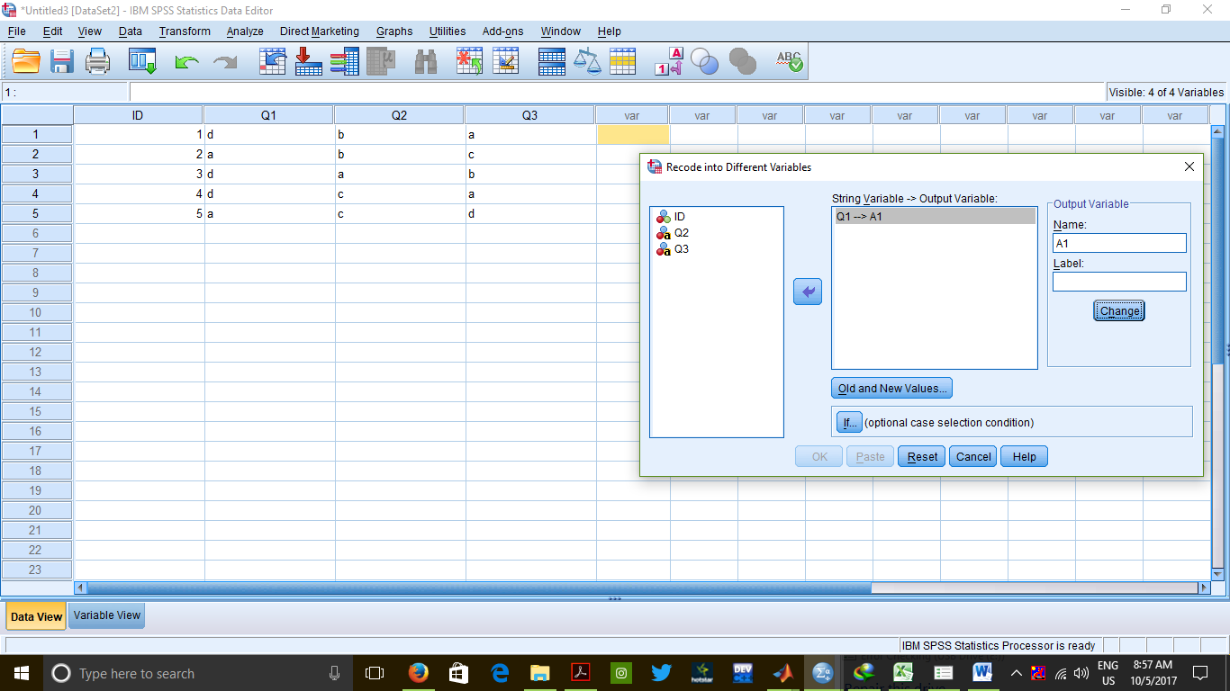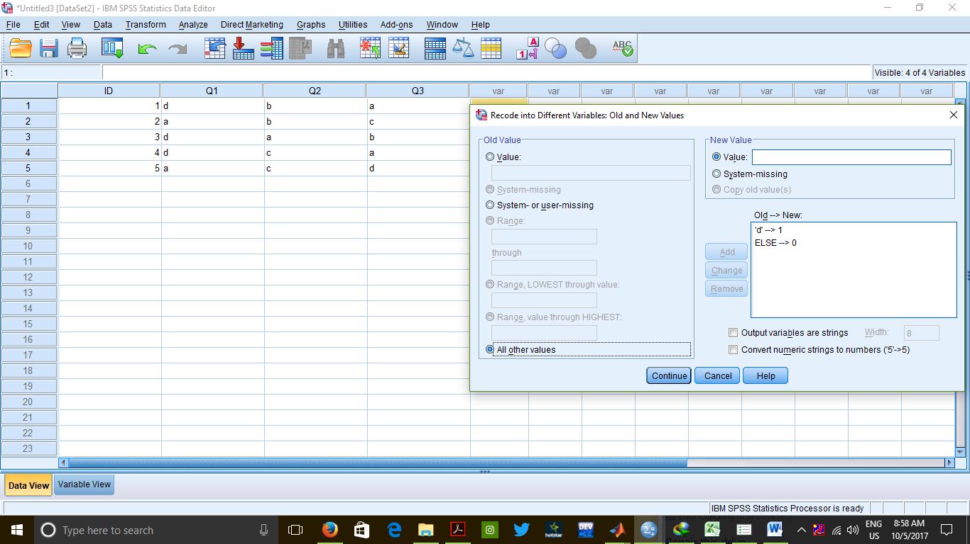

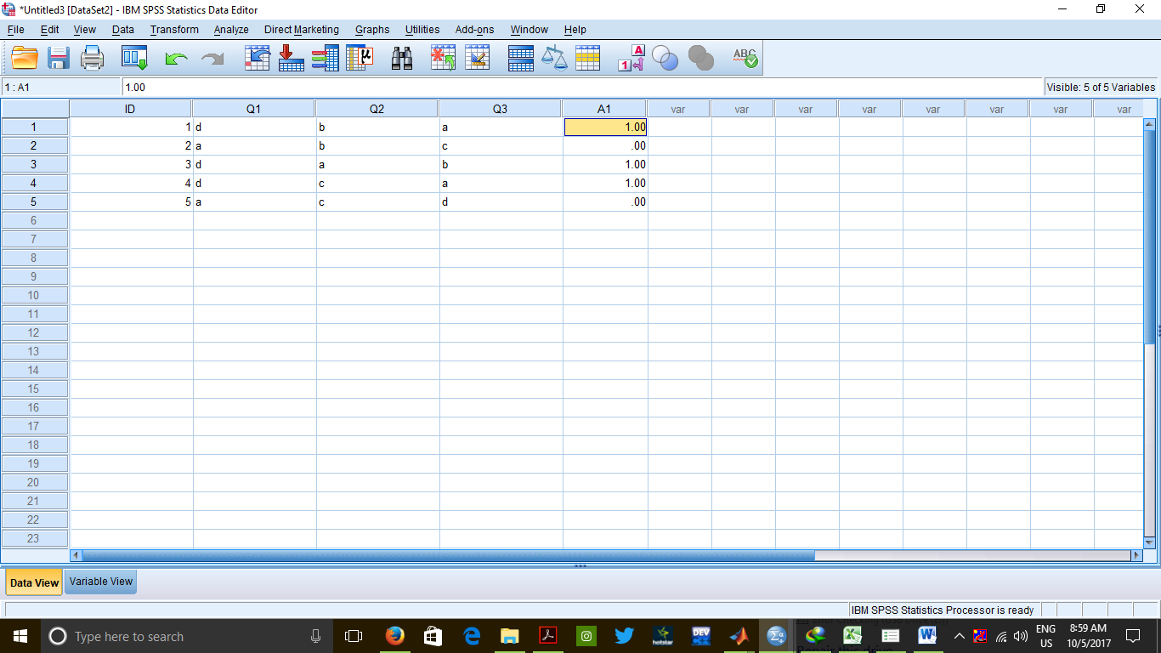

Similarly with variable Q2 and Q3

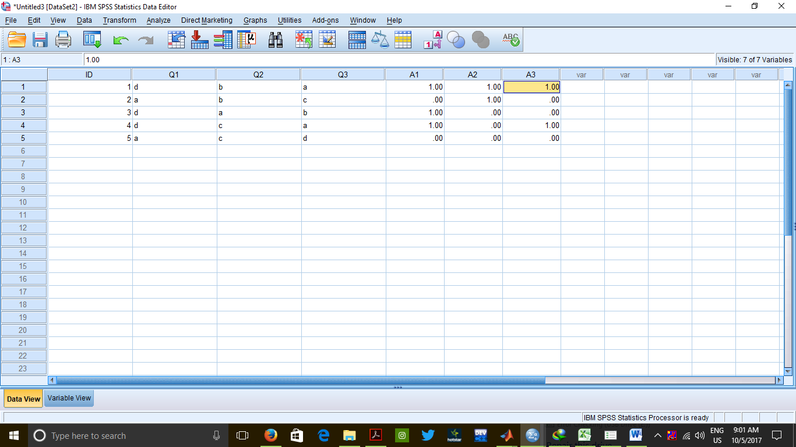

To find result we do it by calculating sum

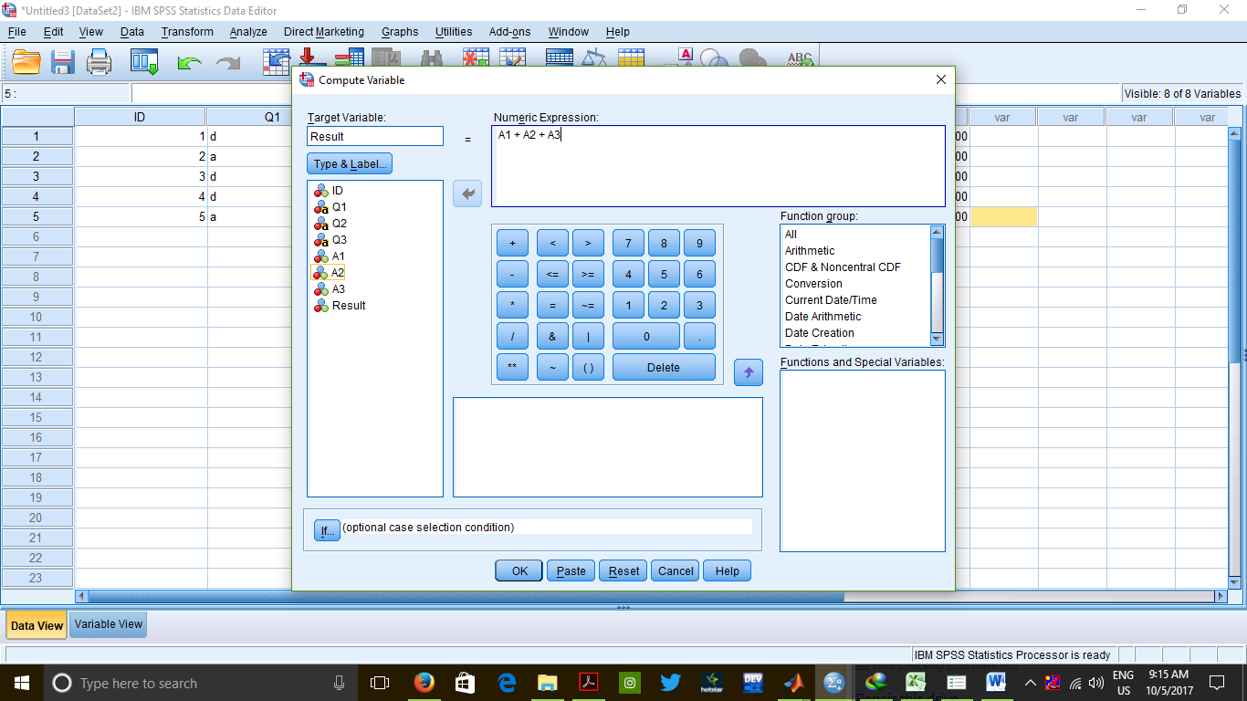

**OUTPUT**

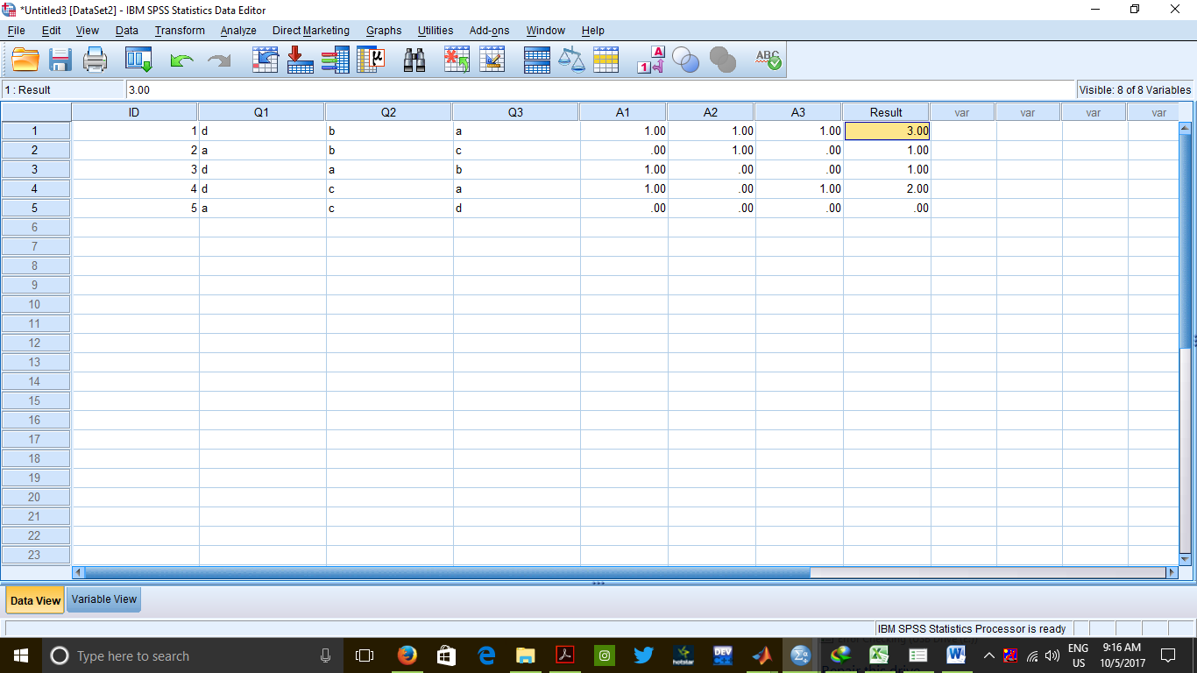

**CONCLUSION** :

New variables have been created on the basis of the answers of the given questions.

Result is computed on the basis of number of questions correctly answered by the

student.

**PRECAUTIONS :**

1. The value of the new variable should be given carefully depending on the correct

answer.

1. The numeric expression for the target variable should be given carefully and properly.

**Practical 7**

**Pictorial representation of data.**

**INPUTS**:

Salesforproduct1.sav

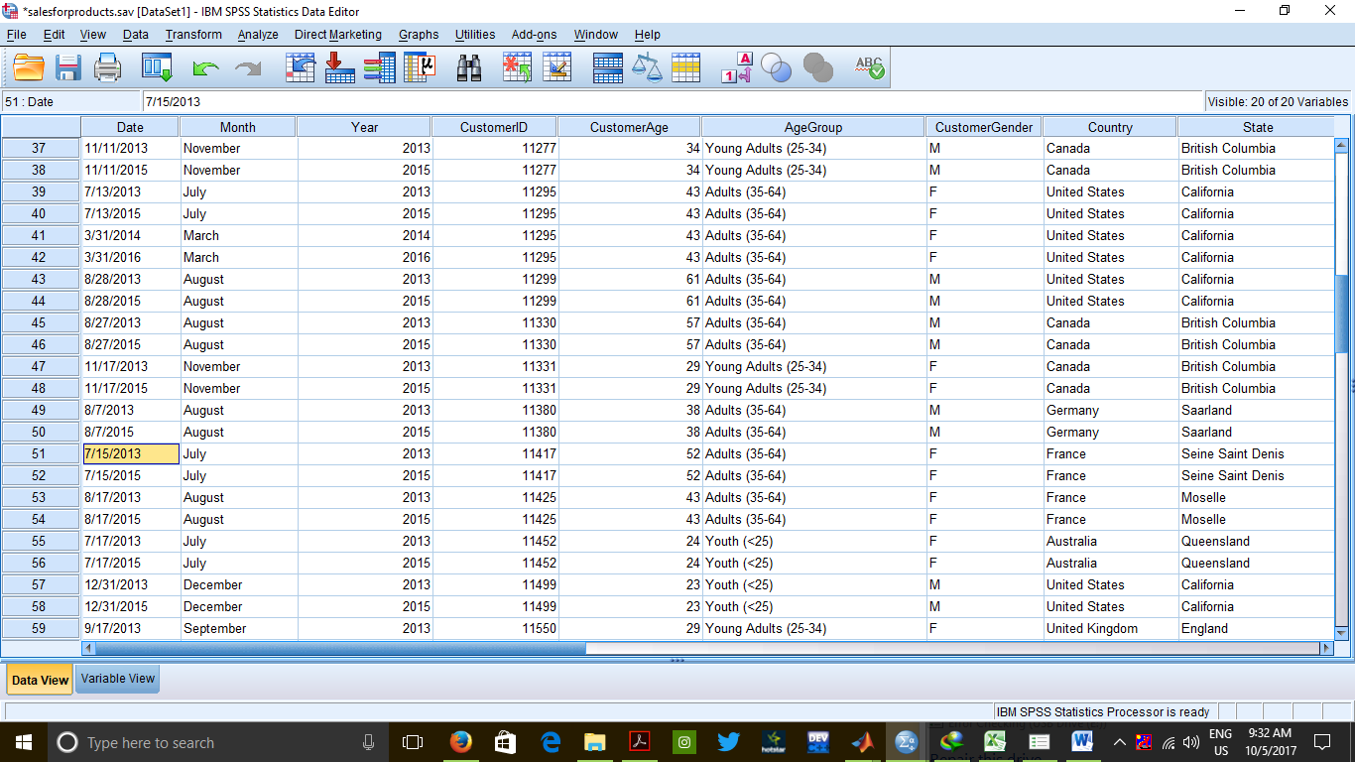

**Data view of input**

**PROCEDURE**:

1. Graphs --> Chart Builder
2. Select and drag the type of graph from the gallery to the Chart Preview.
3. Select and drag the variables accordingly to the Chart Preview. Click on the button saying "Element Properties...". Edit any properties, if required, in the dialog box that opens.
4. Press "Close" when done editing.
5. Press "OK" and the graph is opened in the output window.
6. Do the same for Histogram, Scatter Plot, Box Plot, Bar Graph & Pie Chart.

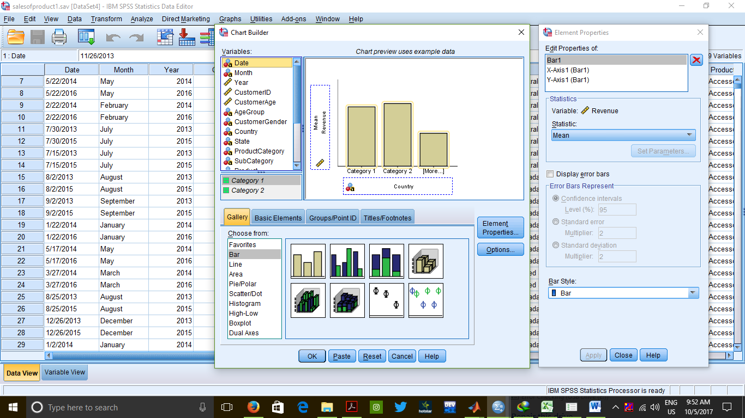

**OUTPUT**

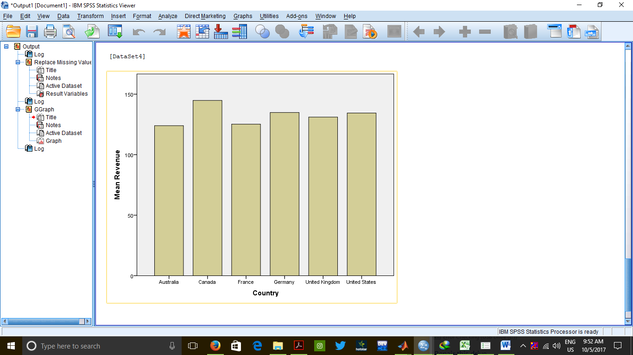

CLUSTERED BAR

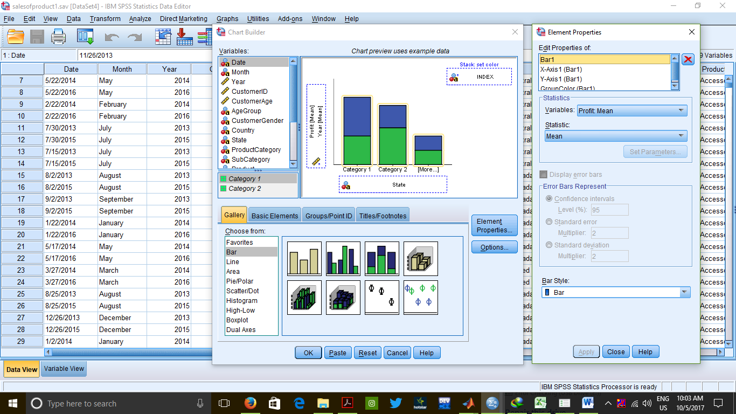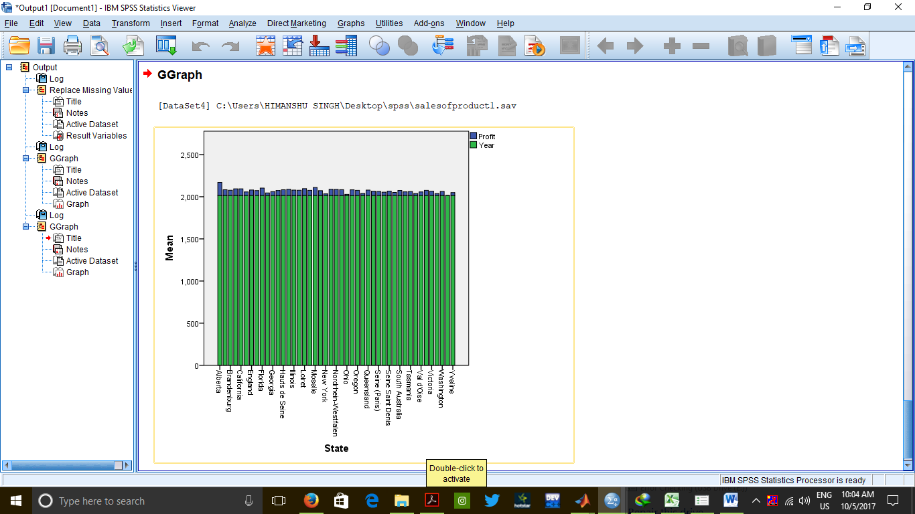

PIE CHART

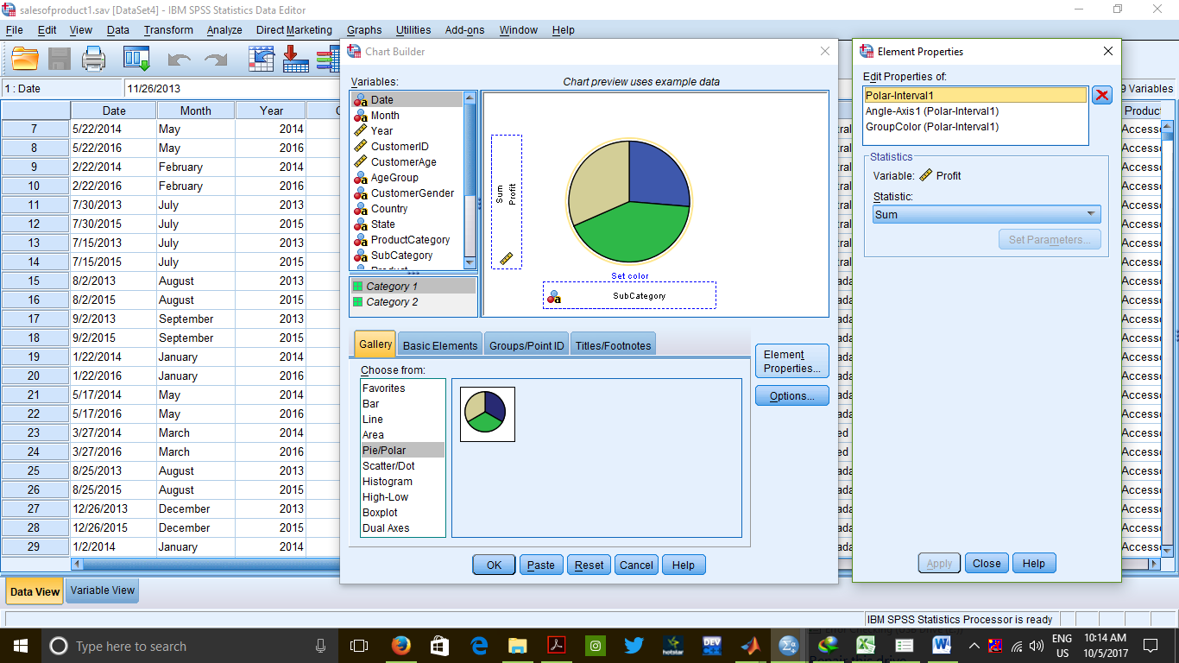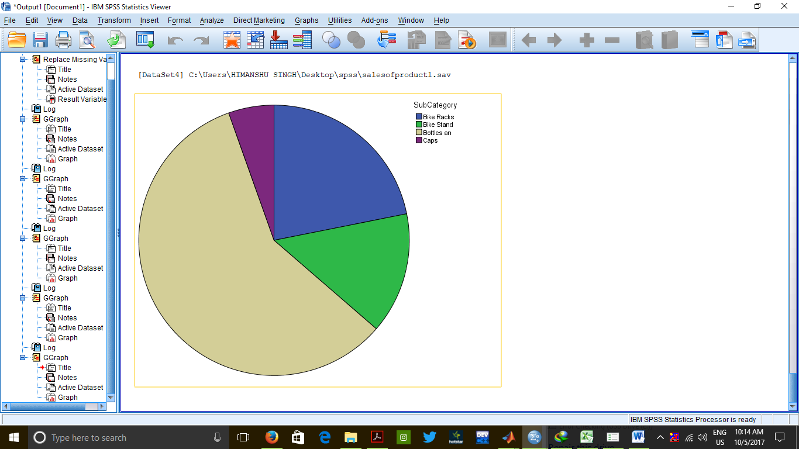

Scatter PLOT

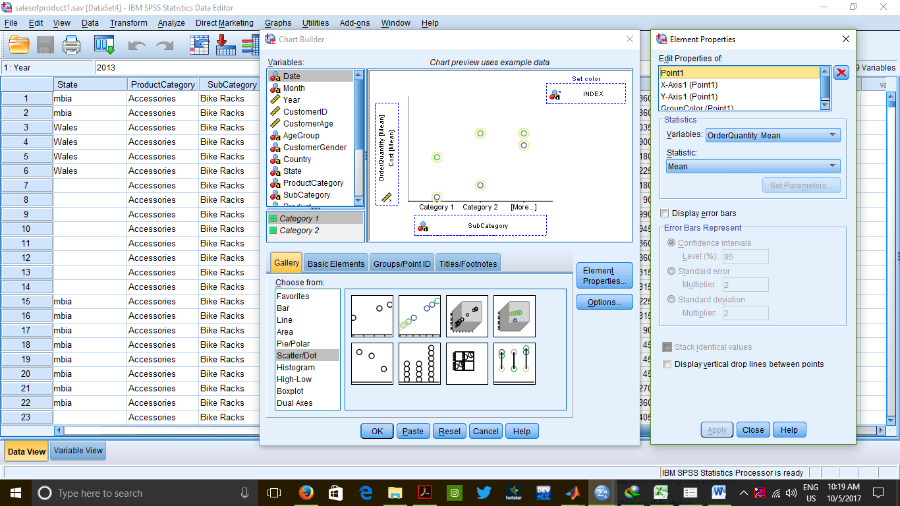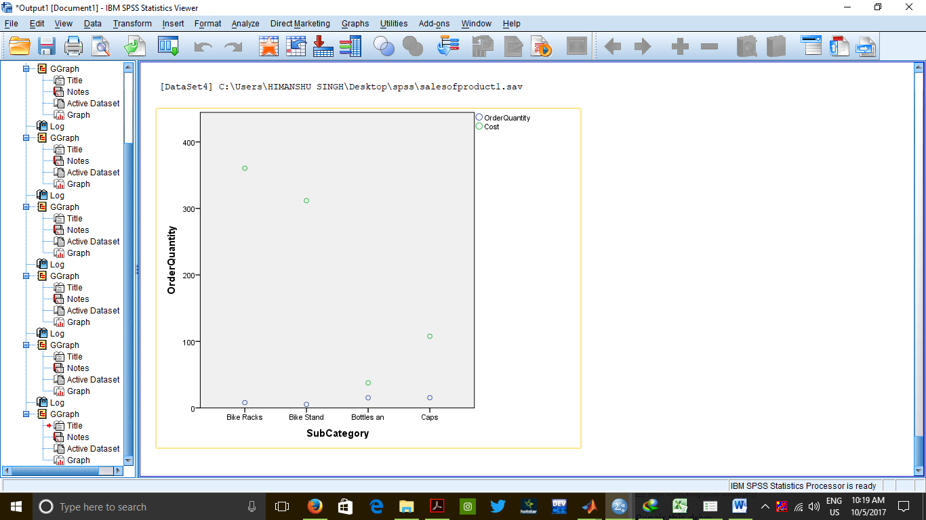

BOX PLOT

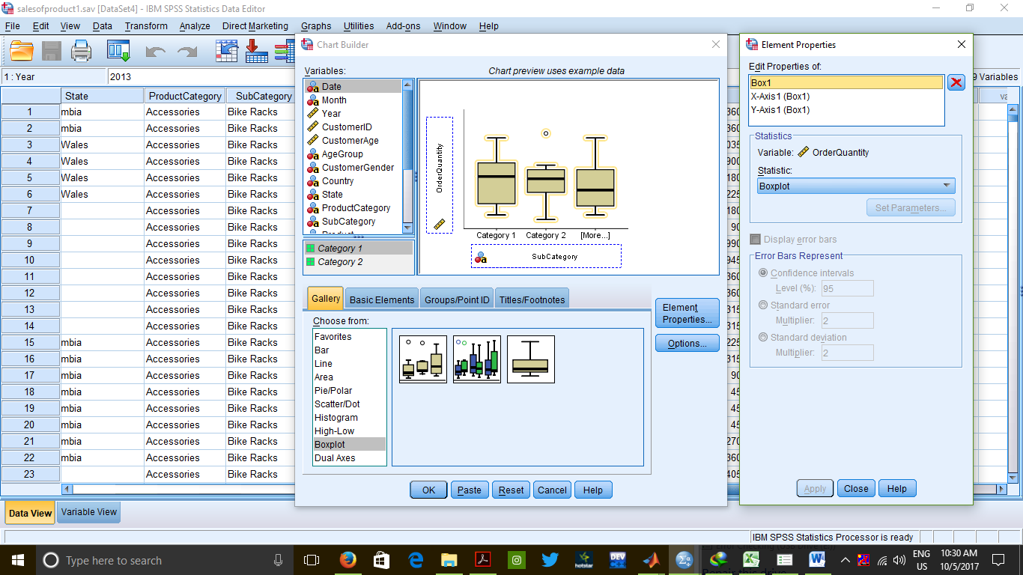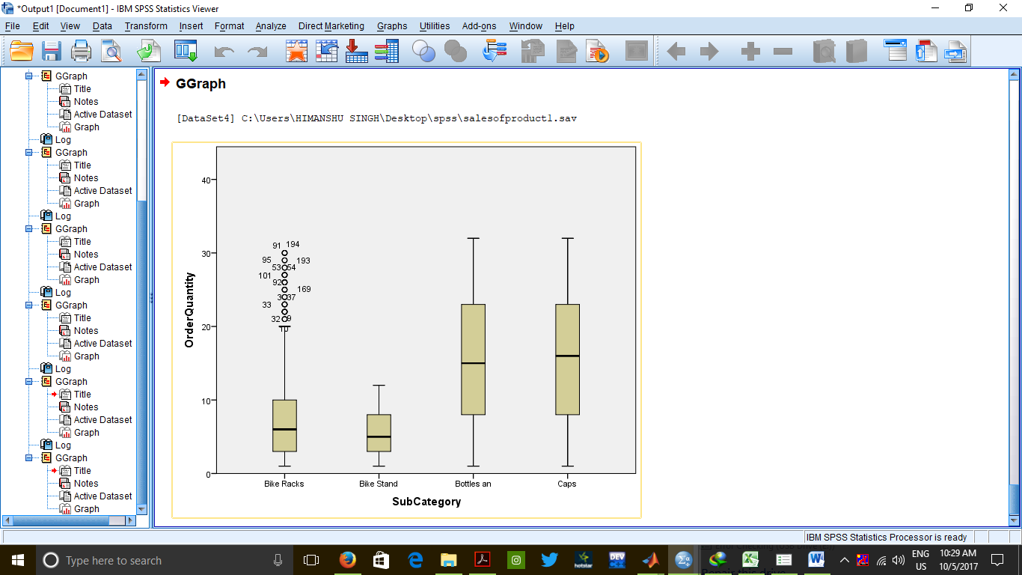

**CONCLUSION :**

We conclude that for any given set of data we can represent it easily with

the help of graphs.

**PRECAUTIONS :**

1. Variables should be chosen carefully during plotting of graphs.
2. Graph labels should be chosen appropriately.